Wired Aerial Theatre
The Higher Space
10 Cotton Street
Liverpool
L3 7DY

May 2017

GENERAL MANAGER RECRUITMENT
Dear Applicant
Thank you for your interest in the position of General Manager at Wired Aerial Theatre. We enclose some background information about the company and its activities, along with the Job Description and Person Specification for this role. We would also be grateful if you would complete the enclosed equal opportunities form, and return it with your application.

To apply for this role we would like you to send us your C.V., along with a covering letter (no longer than 2 sides of A4), explaining how you feel you would be able to undertake the key tasks outlined; also addressing the essential and desirable criteria in the personal specification as appropriate. Please note, that a C.V. arriving without a cover letter will
not be considered. Please also complete and attach the Equal Opportunities monitoring form, found at the end of this document.

This is a new role for the company and we are excited to find a dynamic individual with as much passion as we have. We are aware that this is a large job description, and so want to assure candidates thinking of applying, that we do not necessarily expect you to have all of the skills listed, and are interested in hearing from candidates from a range of backgrounds; we are also willing to shape the role to suit the individual. The successful candidate will also be supported by the two company directors and our Manchester based Producers XTRAX, as well as being offered any training and development that was deemed appropriate.

If you need any more information about the role, or would just like to discuss your application then candidates are welcome to call Chris Bryerley, General Manager at XTRAX on 0161 227 8383.

Please read through the enclosed information carefully, and return your completed
application, marked General Manager - Private & Confidential to us at admin@wiredaerialtheatre.com .

The closing date for completed applications is: Monday 3rd July at 9am.
Interviews will be held on the week commencing on 10th July at The Higher Space.

Good luck with your application, and thanks for your interest in Wired Aerial Theatre.

All the best

Wendy and Jamie Ogilvie

Wendy and Jamie Ogilvie
(Artistic and Technical Directors)

General Information for Candidates
Company Background:
Wired Aerial Theatre creates and delivers inspirational aerial performance. Based in Liverpool at its centre for aerial excellence (The Higher Space) and touring nationally and internationally, the company delivers a varied programme of work including indoor and outdoor performance, education, training, workshops and consultancy. Wired Aerial Theatre is supported by Arts Council England and has been a National Portfolio Organisation since April 2015. We are currently making plans for the next 5 years and we are planning to expand our team to help us deliver our vision.

Wired Aerial Theatre is a company limited by guarantee with a small Board of Directors. The company is led by its two founders and Directors, Artistic Director Wendy Ogilvie, and Technical Director Jamie Ogilvie. The post holder will work closely with the Directors, management team, and other staff members on all aspects of the management of projects, ensuring successful delivery and providing the managerial backbone of the company. The role will be based at the company’s office in Liverpool with some travel required. Wired has a contract with XTRAX, based in Manchester, for provision of producer and management services. As Wired’s work is growing this General Manager post is being created to complement the services provided by XTRAX and to increase the capacity of the company.

The Candidate:
We’re looking for an ambitious candidate with excellent organisational and leadership skills who is keen to take on a challenge and to make an impact within a dynamic and entrepreneurial organisation. The ideal post-holder will have at least 2-years of experience in a similar role; an interest in the arts sector; be confident with budgets and financial management; and have an eye for developing creative opportunities. Excellent communication, organisation and time management skills are also a necessity in this fast-paced office environment. This is a new role in a developing company and we are looking for a candidate with lots of ideas, drive and determination; who is keen to make their mark on an exciting organisation.
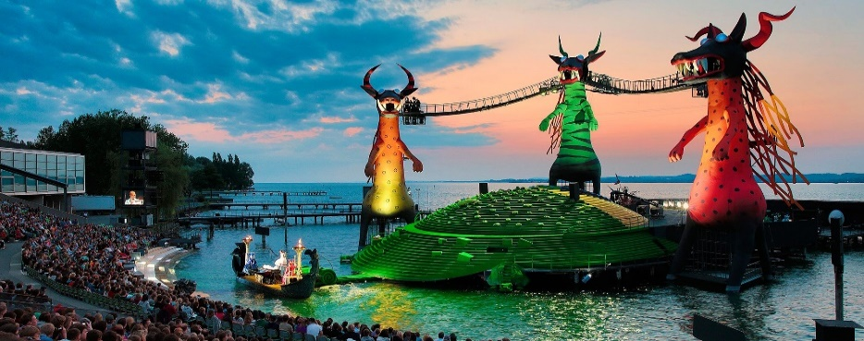
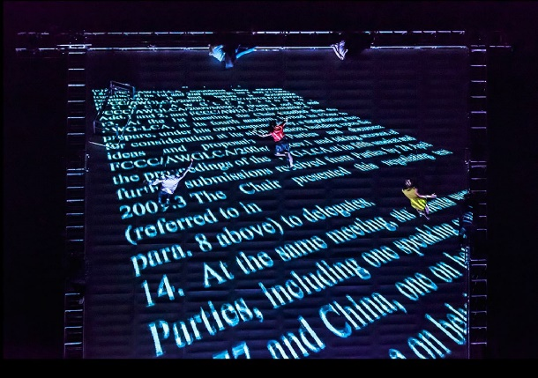
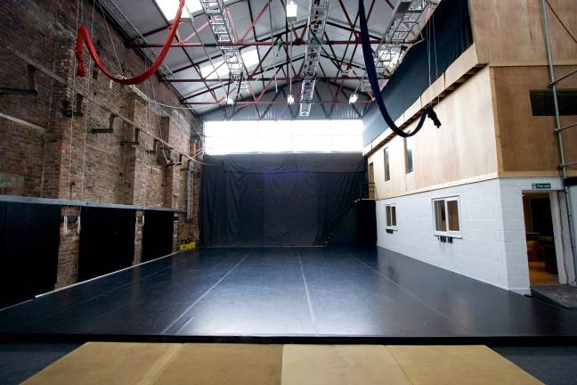

Key projects for 2017 and beyond:
We are developing a range of exciting indoor and outdoor performance projects for the coming years, including:
- Touring of our large scale outdoor show, As the World Tipped
- Pioneering Education work Edge Hill and Liverpool Institute for the Performing Arts (LIPA) – Wired delivers aerial performance modules to students at these prestigious education centers
- The Higher Space – Continuous development and programming of Wired’s center of aerial excellence
- Small /Middle scale outdoor work: development of new productions for touring to outdoor festivals
- Bregenz Opera – A 2-year contract in which Wired will supply an aerial team and offer consultancy for the aerial aspects of a new production for this internationally renowned Opera festival in Austria
- New large-scale work – Development of a new large-scale outdoor and Indoor show
- General company development
- Other consultancy, events and contracted projects

Access:
Our office has level access to the ground floor area and toilets. The office and kitchen area is on the first floor accessed by stairs. We welcome applications from disabled people but please note there are access restrictions in our building.

For more information on Wired Aerial Theatre please visit: www.wiredaerialtheatre.com
To see the Bregenz set being built live please visit: www.bregenzerfestspiele.com/en/webcam

Job Description
Terms of Employment
Employer: | Wired Aerial Theatre
Job Title: | General Manager
Contract Type: | Permanent, subject to the successful completion of a 6-month probationary period and review
Salary: | £27,000 - £30,000 depending on experience
Location: | The Higher Space,10 Cotton Street, Liverpool, L3 7DY
Hours: | Full time, 35 hrs/week - office hours are 9am – 5pm. The responsibilities of the post may include some evening and weekend work from time to time (TOIL is offered)
Notice Period: | 3 months
Responsible to: | Company Directors and Board of Directors
Responsible for: | Company Administrator

Applications:
To apply please send your CV with a covering letter (no longer than 2 pages) explaining how you meet the requirements of this role to admin@wiredaerialtheatre.com
Deadline: | Monday 3rd July at 9am
Shortlisting: | Candidates will be shortlisted and invited to interview by Thursday 6th July
Interviews: | Candidates will be invited to the Higher Space on the week commencing 10th July

Main Purpose of Post:
The General Manager will provide the managerial backbone for Wired in the delivery of all its work, keeping an organisational overview whilst also ensuring that all projects are delivered effectively.
Roles and Responsibilities:

- Business Development
- Alongside Directors develop and implement the company’s 2018-22 business plan
- Proactively explore opportunities for fundraising and revenue development
- Ensure that the company’s objectives are being met through regular monitoring and strategic reviewing
- Act as champion for the company, proactively engaging in regional and national networks

- Financial
- Alongside Directors develop and manage company and project budgets and cashflow projections
- Supervise the Administrator in all bookkeeping activity
- Produce quarterly management accounts for the Board of Directors and funders
- Be responsible for banking and ensuring invoices are paid
- Work with external accountants on monthly payroll including pensions contributions
- Work with external accountants on quarterly VAT returns
- Work with external accountants on annual report and accounts
- Seek out, and contribute to the preparation of, funding applications

- HR and Staff
- Maintain and develop HR systems, policies, and procedure
- Review and update all staff personnel records and freelance contracts
- Alongside the Directors manage recruitment and appraisal processes
- Supervise the work of the Administrator
- Oversee staff training and professional development
- Manage staff holiday and TOIL
- Take an overview of the company calendar

- Contracting and Reporting
- Alongside Directors prepare and manage project, touring and service contracts
- Ensure Wired meets the requirements laid out in contracts and funding agreements
- Ensure adequate insurance cover is in place
- Prepare management reports for the Board of Directors and funders
- Ensure that data gathering systems are in place for reporting to key funders
- Supervise appropriate evaluation processes for projects

- General
- Represent Wired at external meetings and events
- Create agendas and lead company meetings
- Oversee specific press and marketing strategies outlined by Directors
- Oversee the company’s IT requirements

- The Higher Space
- Alongside the Directors create and implement a commercial plan for THS
- Work closely with Directors and Education Coordinator to ensure Emerging Artist Support Scheme is running well
- Oversee running costs of the space

We recognise that this is an extensive Job Description, covering all areas of the organization, but support and/or training will be given if required.

Person Specification
Essential:
- At least 2-years’ experience working in a similar role
- Experience of financial management, budget development and cashflow forecasting
- Excellent administrative, organizational, and time management skills
- Excellent verbal and written communication skills
- Experience of contract management
- A problem solving, can-do attitude
- Ability to use standard Microsoft IT packages,
- High levels of attention to detail
- Ability to work under pressure
- Ability to handle multiple projects, priorities and deadlines simultaneously
- Ability to work independently, unsupervised or in a team, to meet targets and deadlines
- Willingness to work some evenings and weekends as required
- Willingness to travel in the UK and potentially internationally

Desirable
- Demonstrable interest in the arts
- Experience of bookkeeping
- Experience of staff management
- An understanding of the arts funding system in the UK
- Experience of UK and international touring
- Experience of festival and event management
- Experience of servicing a Board of Directors
- Experience of working with artists
- Experience of Fundraising
- Hold a valid driver’s licence
- A spoken second language

Equal Opportunities Form
Wired Aerial Theatre is committed to promoting equality of opportunity in its employment practices and aims to ensure that no potential or actual employee receives more or less favourable treatment on the grounds of race, colour, ethnic or national origins, marital status, sex, sexual orientation, age, disability or religious beliefs.

In order to monitor our policy and to assist its development, we would be grateful if you would complete this form and return it with your application. Completion of the form is voluntary. Returned forms will be separated from job applications and used solely for monitoring purposes.

The information collected will be treated in the strictest confidence and will be used only for the purpose of furthering and improving Wired Aerial Theatre’s equal opportunities policy.

Post applied for:

Gender:
- Male
- Female

Age:
- 18-25
- 25-34
- 35-44
- 45-54
- 55-64
- 65+

Ethnic origin:
White British
- English
- Irish
- Welsh
- Scottish
- Any other white background. Please state.

Asian or Asian British
- Asian Bangladeshi
- Asian Indian
- Asian Pakistani
- Any other Asian background. Please state.

Black or Black British
- Black African
- Black Caribbean
- Any other Black background. Please state.

Chinese or other ethnic group
- Chinese
- Any other. Please state.

Dual heritage:
- Dual Asian and White
- Dual Black African and White
- Dual Black Caribbean and White
- Dual Chinese and White
- Any other dual heritage background. Please state.
- Any other background. Please state.

Do you consider yourself to have a disability?
- YES
- NO

If yes please state the nature of the disability.

Do you consider yourself to have a hidden disability?
- YES
- NO

If yes please state the nature of the disability.

Please tell us where you saw this post advertised:

THANK YOU FOR COMPLETING THIS FORM

