Wired Aerial Theatre
The Higher Space
10 Cotton Street
Liverpool
L3 7DY

May 2017

COMPANY ADMINISTRATOR RECRUITMENT
Dear Applicant
Thank you for your interest in the position of Company Administrator at Wired Aerial Theatre. We enclose some background information about the company and its activities, along with the Job Description and Person Specification for this role. We would also be grateful if you would complete the enclosed equal opportunities form, and return it with your application.

To apply for this role we would like you to send us your C.V., along with a covering letter (no longer than 2 sides of A4), explaining how you feel you would be able to undertake the key tasks outlined; also addressing the essential and desirable criteria in the personal specification as appropriate. Please note, that a C.V. arriving without a cover letter will
not be considered.

Please read through the enclosed information carefully, and return your completed application, marked Company Administrator - Private & Confidential to us at admin@wiredaerialtheatre.com

The closing date for completed applications is: Monday 3rd July at 9am.
Interviews will be held on the week commencing on 10th July at The Higher Space.

Good luck with your application, and thanks for your interest in Wired Aerial Theatre.

All the best

Wendy and Jamie Ogilvie

Wendy and Jamie Ogilvie
(Artistic and Technical Directors)

General Information for Candidates
Company Background:
Wired Aerial Theatre creates and delivers inspirational aerial performance. Based in Liverpool at its centre for aerial excellence (The Higher Space) and touring nationally and internationally, the company delivers a varied programme of work including indoor and outdoor performance, education, training, workshops and consultancy. Wired Aerial Theatre is supported by Arts Council England and has been a National Portfolio Organisation since April 2015. We are currently making plans for the next 5 years and we are planning to expand our team to help us deliver our vision.

Wired Aerial Theatre is a company limited by guarantee with a small Board of Directors. The company is led by its two founders and Directors, Artistic Director Wendy Ogilvie, and Technical Director Jamie Ogilvie. The post holder will work closely with the Directors, management team, and other staff members on administrative aspects of our artistic projects and education programmes. The role will be based at the company’s office in Liverpool with some travel occasionally required.

The Candidate:
We’re looking for someone with excellent communication, organisation and time management skills, someone who has prior experience of working in a fast-paced office environment. We require someone who has strong interpersonal skills, is capable of juggling multiple priorities, and who can work well under pressure.

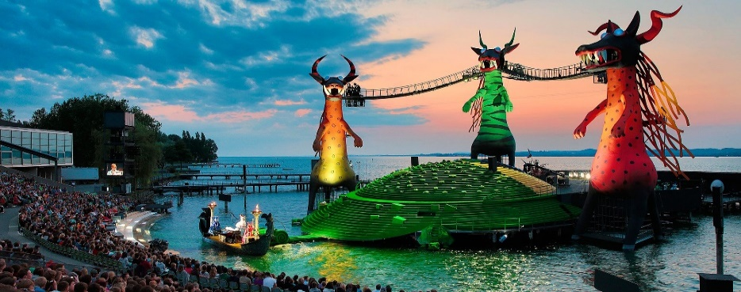
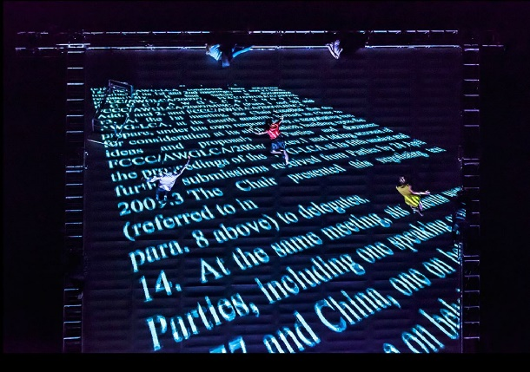
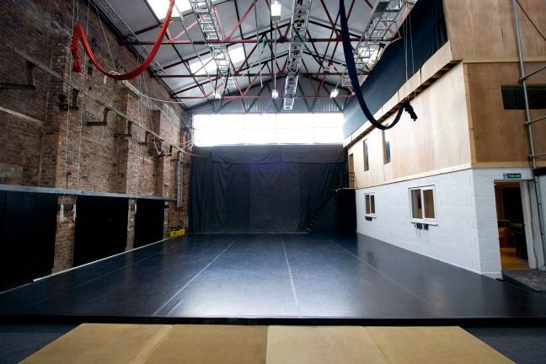

Key projects for 2017 and beyond:
We are developing a range of exciting indoor and outdoor performance projects for the coming years, including:
- Touring of our large scale outdoor show, As the World Tipped
- Pioneering Education work Edge Hill and Liverpool Institute for the Performing Arts (LIPA) – Wired delivers aerial performance modules to students at these prestigious education centers
- The Higher Space – Continuous development and programming of Wired’s center of aerial excellence
- Small /Middle scale outdoor work: development of new productions for touring to outdoor festivals
- Bregenz Opera – A 2-year contract in which Wired will supply an aerial team and offer consultancy for the aerial aspects of a new production for this internationally renowned Opera festival in Austria
- New large-scale work – Development of a new large-scale outdoor and Indoor show
- General company development
- Other consultancy, events and contracted projects

Access:
Our office has level access to the ground floor area and toilets. The office and kitchen area is on the first floor accessed by stairs. We welcome applications from disabled people but please note there are access restrictions in our building.

For more information on Wired Aerial Theatre please visit: www.wiredaerialtheatre.com

Job Description

Terms of Employment
Employer: | Wired Aerial Theatre
Job Title: | Company Administrator
Contract Type: | 1 year fixed term contract with likelihood of extension (subject to funding)
Salary: | £17-19,500, depending on experience (full time)
Location: | The Higher Space,10 Cotton Street, Liverpool, L3 7DY
Hours: | Full time, 35hrs/week - office hours are 9am – 5pm. The responsibilities of the post may include some evening and weekend work from time to time (TOIL is offered)
Notice Period: | 2 months
Responsible to: | General Manager

Applications:
To apply please send your CV with a covering letter (no longer than 2 pages) explaining how you meet the requirements of this role to admin@wiredaerialtheatre.com

Deadline: | Monday 3rd July at 9am
Shortlisting: | Candidates will be shortlisted and invited to interview by Thursday 6th July
Interviews: | Candidates will be invited to the Higher Space on the week commencing 10th July

Roles and Responsibilities:

Administration:
- Provide administrative support to the Directors, General Manager and staff team
- Act as the first point of contact for general enquiries
- Respond to correspondence and requests via the telephone and email
- Organise meetings, circulating agendas and relevant papers, and taking minutes
- Manage Wired’s digital and paper filing systems
- Ensure office equipment is maintained
- Oversee accident and near miss reports
- Manage and maintain the company contact database
- Develop good relationships with suppliers, clients, freelancers and tutors
- Book company travel and accommodation
- Ensure stationary and consumables are replenished
- Assist in data collection for funders reporting

Financial:
Alongside the General Manager:
- Undertake elements of bookkeeping on the Free Agent software (this is much easier than traditional bookkeeping software such as Sage, and in-house training will be provided)
- Ensure that invoices and receipts are filed
- Request and log staff expenses
- Log workshop and hire income

Hires, Events and Workshops:
- Alongside the General Manager, facilitate the external hiring of The Higher Space
- Ensure all visitors to The Higher Space complete booking, feedback and monitoring forms
- Handle workshop bookings, ensuring payments are received
- Prepare weekly registers and emergency contact sheets for class tutors
- Review feedback on report sheets and relay to Directors / Education Coordinator
- Assist with specific workshop activity as requested by the Directors
Marketing:
Assist the General Manager with the marketing and communication strategies including:
- Manage social media activity including Facebook, Twitter and Instagram
- Draft and distribute regular company newsletters
- Manage and develop website content – ensuring all areas of the website are up-to-date with current activities
- Manage the company’s image archive

Other Duties:
- Be responsible for The Higher Space keys and ensure they are logged accordingly
- Attend company meetings
- Attend in-house training and professional development sessions with the company
- Occasionally represent the company at events and regional networking meetings
- Such other duties as necessary to ensure the smooth running of Wired Aerial Theatre and The Higher Space

Person Specification

We are looking for someone with the following aptitudes and experience:
Essential
- At least two years’ experience of working in an office environment ideally in an arts/events organisation
- Excellent verbal and written communication skills
- Excellent organisational and time management skills
- Experience of basic financial management
- Experience of basic marketing delivery including social media
- A problem solving, can-do attitude
- Ability to use standard Microsoft IT packages,
- High levels of attention to detail
- Ability to work under pressure
- Ability to handle multiple projects, priorities and deadlines simultaneously
- Ability to work independently, unsupervised or in a team, to meet targets and deadlines

Desirable
- An interest in the arts and events
- Experience of bookkeeping systems – we use Free Agent (but in house training will be provided)
- Experience of design including Photoshop, Illustrator (or equivalent)
- Hold a current first aid certificate.
- Hold a valid driver’s licence
- Experience of working on festivals and events
- Experience of database management
- A spoken second language
- Experience of working with artists

Equal Opportunities Form
Wired Aerial Theatre is committed to promoting equality of opportunity in its employment practices and aims to ensure that no potential or actual employee receives more or less favourable treatment on the grounds of race, colour, ethnic or national origins, marital status, sex, sexual orientation, age, disability or religious beliefs.

In order to monitor our policy and to assist its development, we would be grateful if you would complete this form and return it with your application. Completion of the form is voluntary. Returned forms will be separated from job applications and used solely for monitoring purposes.

The information collected will be treated in the strictest confidence and will be used only for the purpose of furthering and improving Wired Aerial Theatre’s equal opportunities policy.

Post applied for:

Gender:
- Male
- Female

Age:
- 18-25
- 25-34
- 35-44
- 45-54
- 55-64
- 65+

Ethnic origin:
White British
- English
- Irish
- Welsh
- Scottish
- Any other white background. Please state.

Asian or Asian British
- Asian Bangladeshi
- Asian Indian
- Asian Pakistani
- Any other Asian background. Please state.

Black or Black British
- Black African
- Black Caribbean
- Any other Black background. Please state.

Chinese or other ethnic group
- Chinese
- Any other. Please state.

Dual heritage:
- Dual Asian and White
- Dual Black African and White
- Dual Black Caribbean and White
- Dual Chinese and White
- Any other dual heritage background. Please state.
- Any other background. Please state.

Do you consider yourself to have a disability?
- YES
- NO

If yes please state the nature of the disability.

Do you consider yourself to have a hidden disability?
- YES
- NO

If yes please state the nature of the disability.

Please tell us where you saw this post advertised:

THANK YOU FOR COMPLETING THIS FORM

